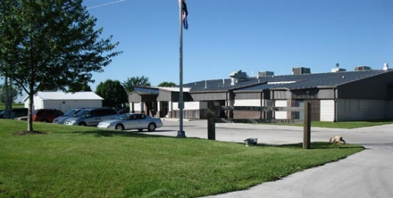
13th Judicial Circuit Court
Robert L. Perry Juvenile Justice Center

.50 FOOD SERVICE WORKER – JUVENILE DETENTION CENTER
Columbia, MO
20 hours a week
Starting wage is $15.00 an hour or $15,600 annually with the potential of a pay increase after a 6-month successful probationary period. This is a benefited part-time position.
We are looking for an energetic person to serve as a Food Service Worker in a juvenile detention center. In this job, you will assist in planning and preparing meals that meet USDA guidelines to be served to young people placed in detention by the courts.
In this position you will get the opportunity to work in a small industrial kitchen. The employee will prepare safe, nutritious meals for youth and staff within the detention facility, coordinate kitchen operations, and supervise youth engaged in the meal clean-up process. Shifts are normally between Monday through Friday from 7:00 a.m. 5:00 p.m. and are coordinated with a full-time Service Worker position.
If you’re looking for an opportunity to provide healthy meals to young people and a job you can turn into a long-term career, then consider joining our team at the Robert L. Perry Juvenile Justice Center. We offer great benefits!
As a Missouri State Paid Employee, you will have the following benefits:
- Health Insurance
- Dental Insurance
- Vision Insurance
- Missouri State Retirement System
- Cafeteria Plan
- Life Insurance
- Paid Time Off
- 14 Paid Holidays per year
Position Responsibilities:
- Prepares meals on a shift in an institutional kitchen; cooking vegetables and meats, baking pastries and making salads.
- Prepares meals on a household or small group basis; observes menu and ordinary rules of nutrition while preparing well balanced meals.
- Maintains sanitary conditions in the kitchen; supervises and participates in the cleaning of stoves, cookers, kettles, pots and pans, refrigerators, food grinders and mixers, work benches and tables and other kitchen utensils and surfaces.
- Requisitions and obtains supplies and menu items as needed, and insures quality and quantity of food, supplies and equipment.
- Ensures that safety and security policies and procedures are followed.
- Must be 21 years of age.
- High school graduate or equivalent.
- One year of commercial, institutional, or large-scale cooking experience.
- Course work or training in cooking or food preparation may be substituted on a month-for-month basis for the required experience.
- Condition of continued employment requires ability to test and pass the Missouri food handlers training.
- Be free from illegal drugs
To Apply:
Applications are available electronically at: http://www.courts.mo.gov/hosted/circuit13/other/jobs.htm
Or
In person at Robert L. Perry Juvenile Justice Center, 5665 N. Roger I. Wilson Memorial Drive, Columbia, Missouri 65202.
Completed applications may be submitted electronically in PDF format to BNE-Jobs-JJC@courts.mo.gov or returned to Robert L. Perry Juvenile Justice Center, 5665 N. Roger I. Wilson Memorial Drive, Columbia, Missouri 65202.
Applications will be accepted until positions are filled.

