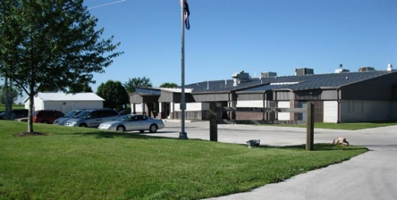**13th Judicial Circuit Court**

**Robert L. Perry Juvenile Justice Center**

**DETENTION AIDE I – JUVENILE DETENTION CENTER**

**Columbia, MO**

**Starting wage is $15.00 an hour or $31,200 annually with a pay increase after a 6-month successful probationary period.**

We are looking for energetic people to serve as Direct Care Staff members of a juvenile detention center. In this job, you will supervise young people who have been placed in detention by the courts and assist in the day-to-day operations of the center.

This job can be difficult at times and requires patience and hard work, but it is extremely rewarding. We will provide all the training you will need to be successful (at no cost to you).

Direct Care Staff directly supervise the residents in the detention center with an emphasis on safety, security, and behavior control. This includes supervising program activities, indoor and outdoor recreation, parental visitation, meals, and personal hygiene. Direct Care Staff also complete required paperwork and other duties as assigned. The position requires availability to work a variety of shifts when needed, including weekends, evenings, and overnights.

If you’re looking for an opportunity to make a difference in the lives of young people and a job you can turn into a long-term career, then consider joining our team at the Robert L. Perry Juvenile Justice Center. We offer great benefits!

**As a Missouri State Paid Employee, you will have the following benefits:**

* Health Insurance
* Dental Insurance
* Vision Insurance
* Missouri State Retirement System
* Cafeteria Plan
* Life Insurance
* Paid Time Off
* 14 Paid Holidays per year
* Missouri Deferred Compensation – Up to $75 per month account matching bonus (optional)

**Position Responsibilities:**

* Serve as a youth supervisor, with responsibility for the safety, personal conduct and care of juveniles during a shift.
* Records and tracks medication provided to the juveniles in detention.
* Coordinates and supervises juvenile work assignments and recreation activities.
* Implement detention center programming.
* Manage youth who exhibit moderate to high risk behaviors including but not limited to chemical dependency, mental illness, trauma, mental health disabilities, physical disabilities, sex offenses, SOGIE, physical ailments, medical needs, language and cultural differences.
* Entry of required data into Missouri’s electronic data collection system.
* Performs Intake assessments and processing of in-custody juveniles.
* Provide secure and safe transportation of juveniles to court or other approved activity.
* Provide drug testing of juveniles when required.
* Performs other related work as assigned.
* Must be 21 years of age.
* High school education, GED, or equivalent with one year of previous experience in the direct care and interaction with children such as YMCA, day care, schools, recreational facilities or residential care programs.
* Be free from illegal drugs
* Clean background check

**To Apply:**

Applications are available electronically at*:* <http://www.courts.mo.gov/hosted/circuit13/other/jobs.htm>

Or

In person at Robert L. Perry Juvenile Justice Center, 5665 N. Roger I. Wilson Memorial Drive, Columbia, Missouri 65202.

Completed applications may be submitted electronically in PDF format to [BNE-Jobs-JJC@courts.mo.gov](mailto:BNE-Jobs-JJC@courts.mo.gov) or returned to Robert L. Perry Juvenile Justice Center, 5665 N. Roger I. Wilson Memorial Drive, Columbia, Missouri 65202.

EOE & in Compliance with ADA