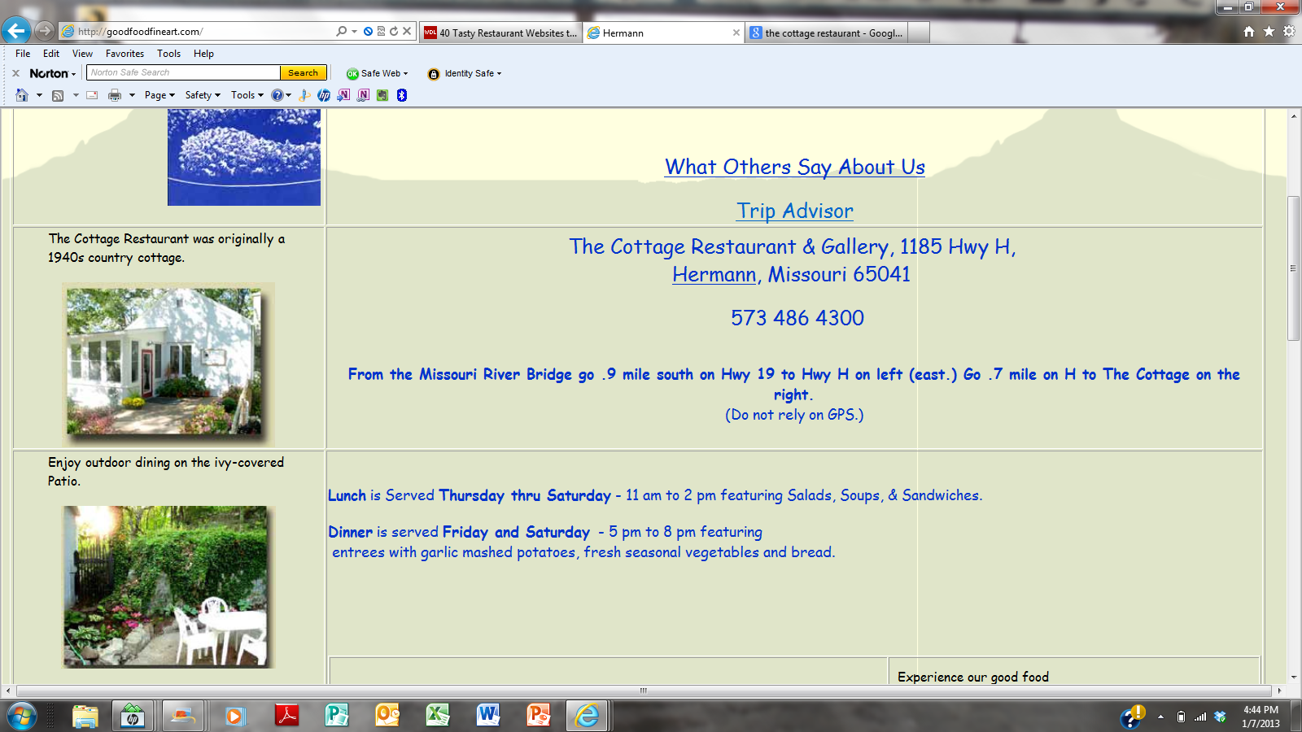**Marigold Bluff**

**Set the Date and let us take it from there!**

* + **Rehearsal Dinner**
  + **Anniversary/Engagement**
  + **Wedding/Baby Shower**
  + **Reunions/Parties**
  + **Company Event**

**Restaurant**

**There’s something pleasing for all palates!**

**Lunch: Wednesday – Saturday, 11a.m. – 2p.m.**

**Dinner: Wednesday – Saturday, 5p.m. – 8:30p.m.**

**Sundays: Brunch: 9a.m. – 1p.m.; Family-Style Dinner: 3p.m. – 6p.m.**

Nestled on a bluff just outside the quaint town of Hermann, Magnolia Bluff Restaurant . . .

Menus

Catering

The Studio